**Sprint 3 Plan: Spotify X Apple Music Blend, 5/7/24**

∙ **Goal:** We want to focus on the third User Story of implementing the ability to play music within the site itself. We also want to improve upon the blend algorithm and the frontend presentation.

User Story 3: As a Lastfm user, I want to be able to play the playlist within the site.

*Task 1: Improve upon the blend algorithm (5 hr)*

*Task 2: Cleaner frontend to present webapp features (6 hr)*

*Task 3: Look into how to play the music in the site (5 hr)*

*Task 4: Implement music player functionality (8 hr)*

*Total for user story 3: 24*

∙ **Team roles:**

*Neha: Project Owner, Developer*

*Kaustubh: Developer*

*Bode: Developer*

*Justin: Developer*

*Chris: Developer, Scrum Master*

*Shayan: Developer*

∙ **Initial task assignment:**

*Neha: User story 3, Task 1*

*Kaustubh: User story 3, Task 3, Task 4*

*Bode: User story 3, Task 3, Task 4*

*Justin: User story 3, Task 3, Task 4*

*Chris: User story 3, Task 1, Task 4*

*Shayan: User story 3, Task 2*

∙ **Initial burnup chart:**

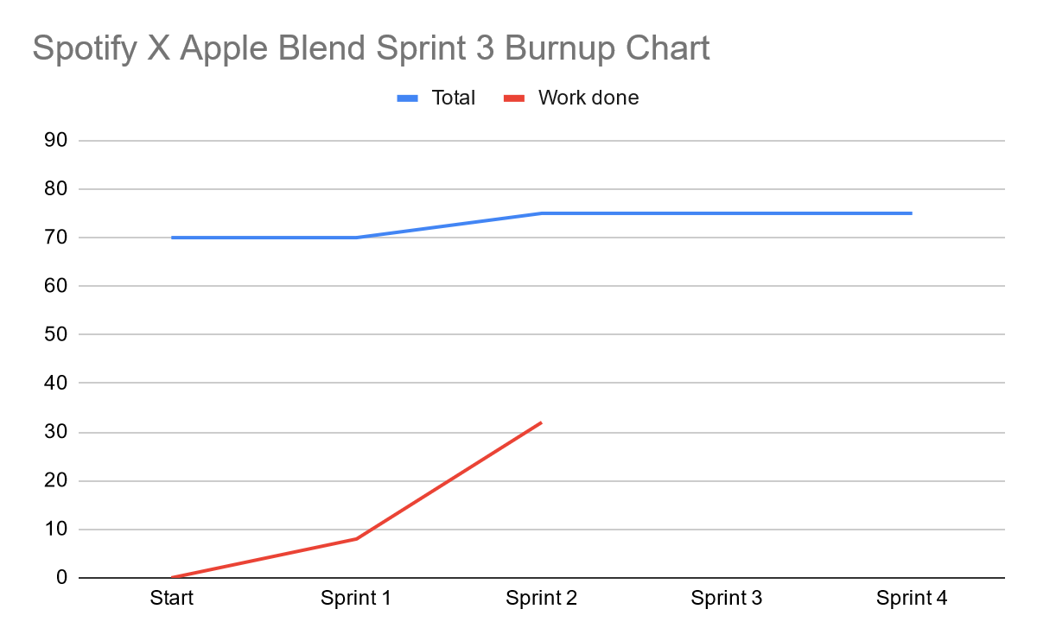

∙ **Initial scrum board:**

| **User Stories** | **Tasks Not Started** | **Tasks in Progress** | **Tasks Completed** |
| --- | --- | --- | --- |
| As a Lastfm user, I want to be able to play the playlist within the site. | * *Task 1: Improve upon the blend algorithm* * *Task 2: Cleaner frontend to present webapp features* * *Task 3: Look into how to play the music in the site* * *Task 4: Implement music player functionality* | * *n/a* | * *[DROPPED] User Story 2: Task 1: Ensure Apple Music calls can be made and received* * *[DROPPED] User Story 2: Task 2: Ensure Apple Music authentication works* * *User Story 2: Task 3: Basic frontend to test server side methods* * *User Story 2: Task 4: Create an algorithm for Blend Logic* * *User Story 2: Task 5: Implement said basic Blend algorithm* * *User Story 2: Task 6: Test Blend algorithm with our accounts and various users* * *[NEW] User Story 2: Task 7: Learn Lastfm API* * *[NEW] User Story 2: Task 8: Ensure Lastfm calls can be made and received* |

∙ **Scrum times:**

* Thursday 6:00 - 7:00 PM TA/tutor meeting
* Saturday 1:00-2:00 PM
* Wednesday 2:00-3:00 PM